**NAME**

**COLLEGE NUMBER**

**Introduction:**

The project is an application of a simple case scenario of CRUD operations (Create, read, update and delete operations), that SQL basically performs on any application. Its silent way to manipulate data on the database without directly interacting with the database manually, say through a DBMS GUI.

The problem:

To use the JAVA Netbeans IDE to create multiple tables and be able to perform CRUD and SQL queries on it.

**The solution process:**

* Xampp as a localhot server was chosen for the project as a preferred DBMS
* A MSQL connector was used to connect the Netbeans IDE to the XAMPP DBMS
* There after queries run on Netbeans

**The Netbeans IDE**

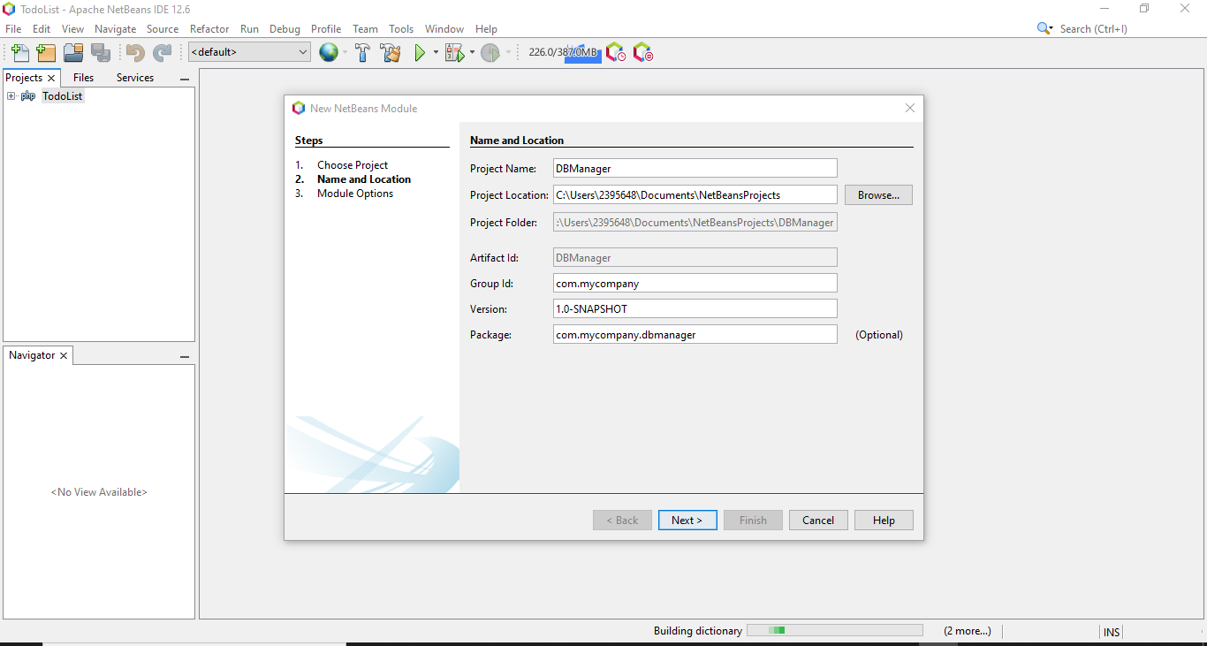

**Establishing connection**

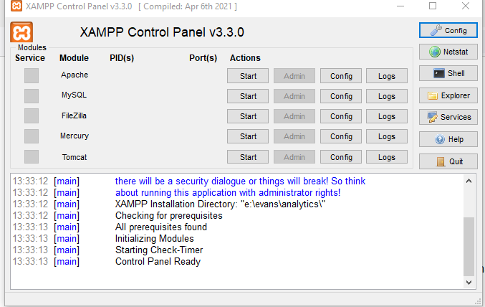

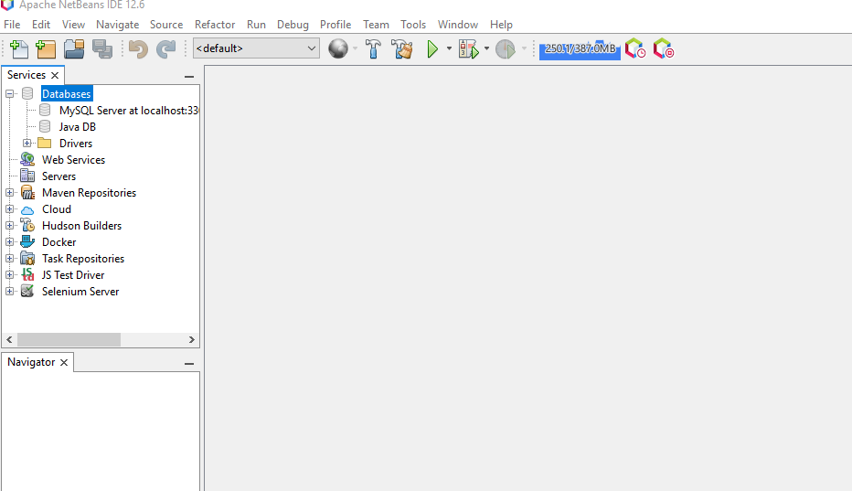

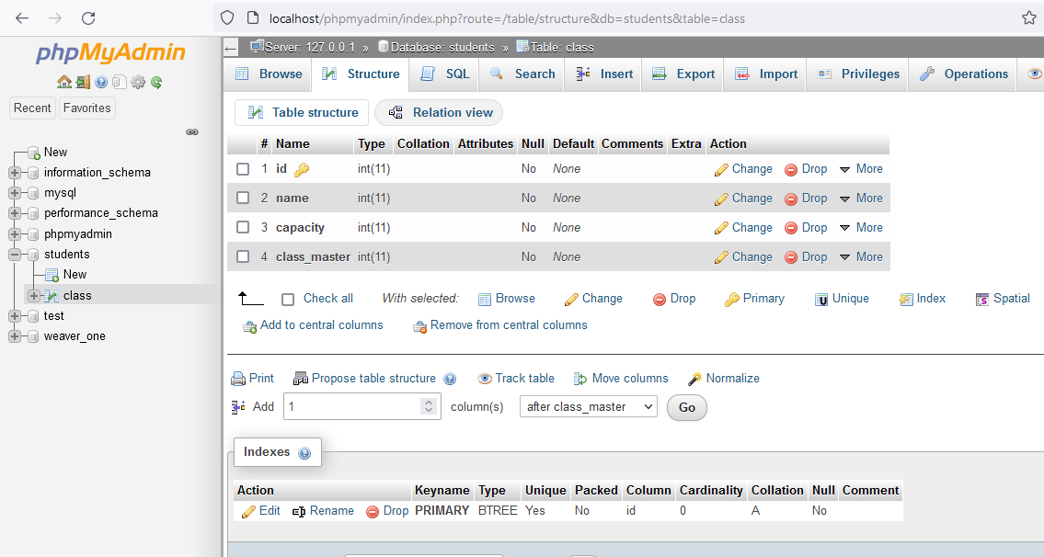

* **Multiple tables on Netbeans Window**

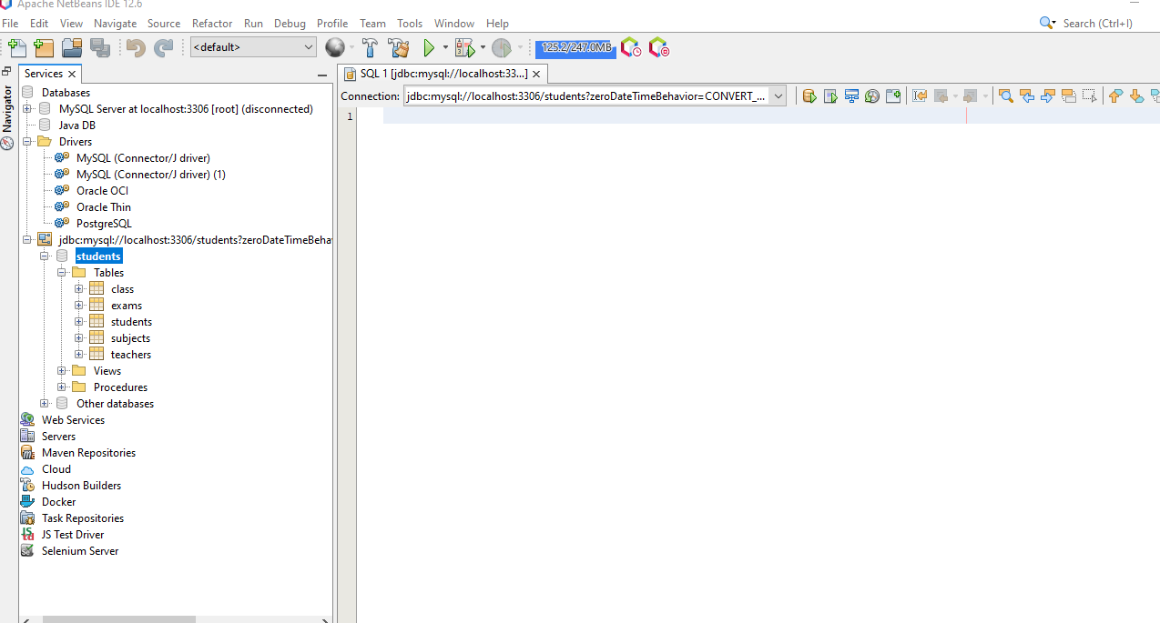

**RUNNING SQL commands**

**CREATTNG TABLES**

* **Trip table**

CREATE TABLE trips

(

trip id INT,

trip_name VARCHAR(255),

trip_location VARCHAR(255),

trip_master VARCHAR(255),

trip_location VARCHAR(25),

trip_date TIMESTAMP,

student_id INT,

);

SELECT * FROM trips;

* **Games table**

---GAMES TABLE

CREATE TABLE games

(

game_id INT,

game_name VARCHAR(255),

game_cap INT,

student_id INT,

game_date  TIMESTAMP(25),

teacher_id INT

);

SELECT * FROM  games;

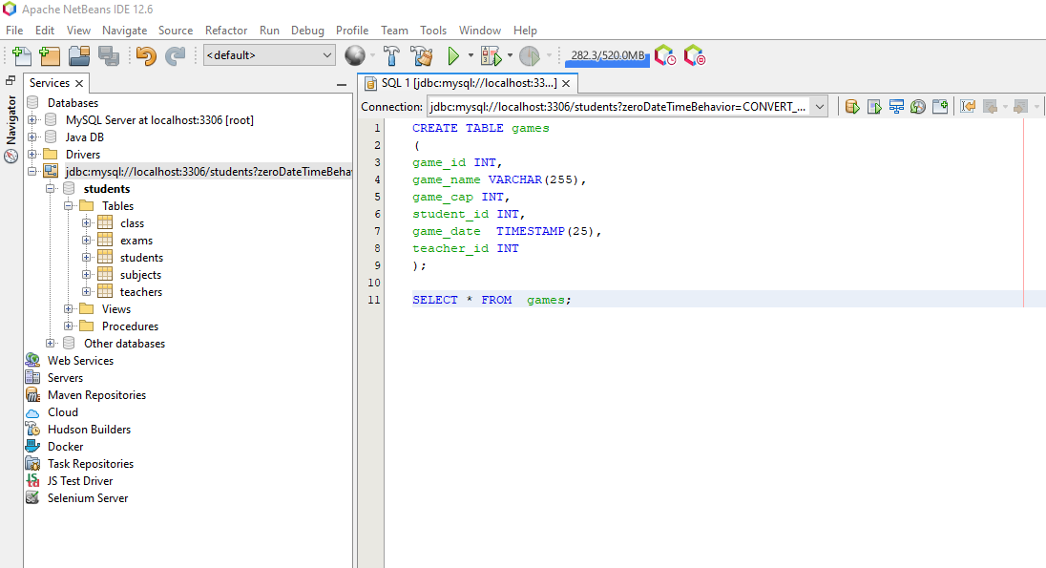

---GAMES TABLE

CREATE TABLE games

(

game_id INT,

game_name VARCHAR(255),

game_location INT,

student_id INT,

game_date  TIMESTAMP(25),

teacher_id INT

);

SELECT * FROM  games;

**All tables here:**

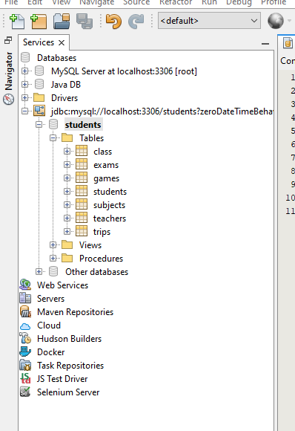

**Security and user management**

--GRANTING user access

GRANT SELECT ON class to user  miniadmin;

**Conducting Normal SQL statements**

* **Getting all the class members**

SELECT * FROM class;

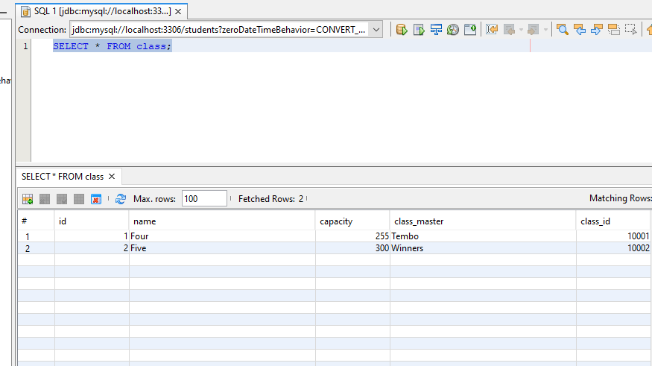

* **Applying the condition clause of “ WHERE’ and “AND”**

SELECT * FROM class

WHERE name = 'Four'

AND capacity = '500'

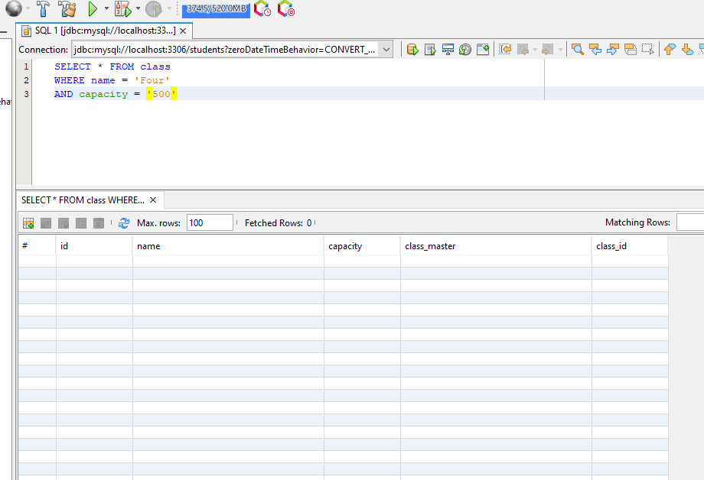

* **Insert records into the students table**

insert into students

(id,s_name,class_id,subject_id)

values

('101','jeremy lynch','10001','201'),

('102','Llian Ace','10002','202'),

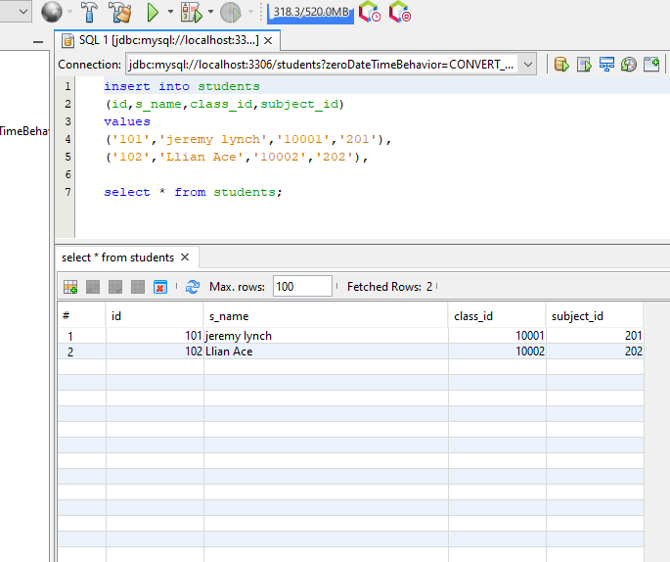

**> Update table records on students table under subject’s column**

--UPDATE STUDENTS TABLE WITH NEW SUBJECT ID RECORD AS 202

update table students set subject_id = '202' where id = '101'

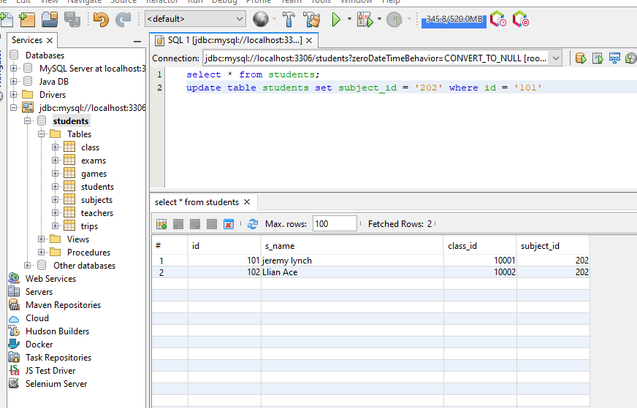

* **TRUNCATE TABLE subjects;**

**Before truncate**

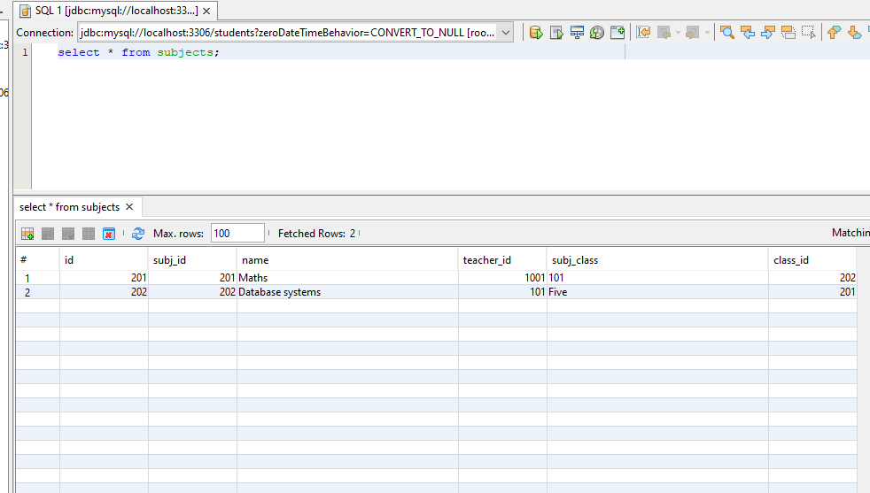

**After ;**

TRUNCATE TABLE subjects immediate;

THEN

select * from subjects;

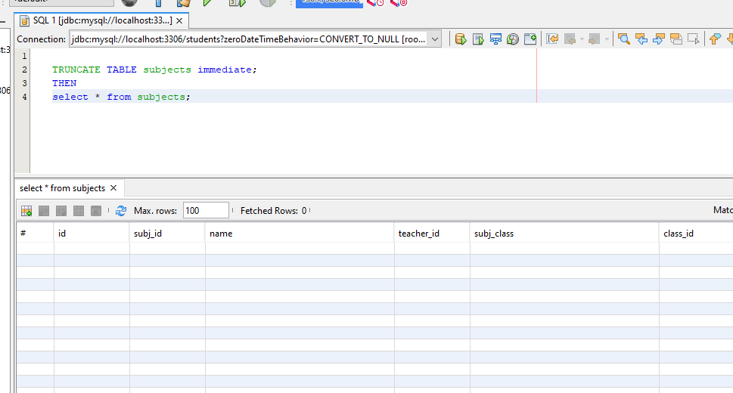

* **Drop table**

DROP TABLE subjects;